**Data-Camp Career Track Data Analyst in Python**

**Course 1: Introduction to Python**

**Python Basics**

**Python as a Calculator**

* 10
* 0
* 15
* 5.0
* 4
* 16
* 194.87171000000012

**Variable Assignment**

**Calculations with variables**

**Python Lists**

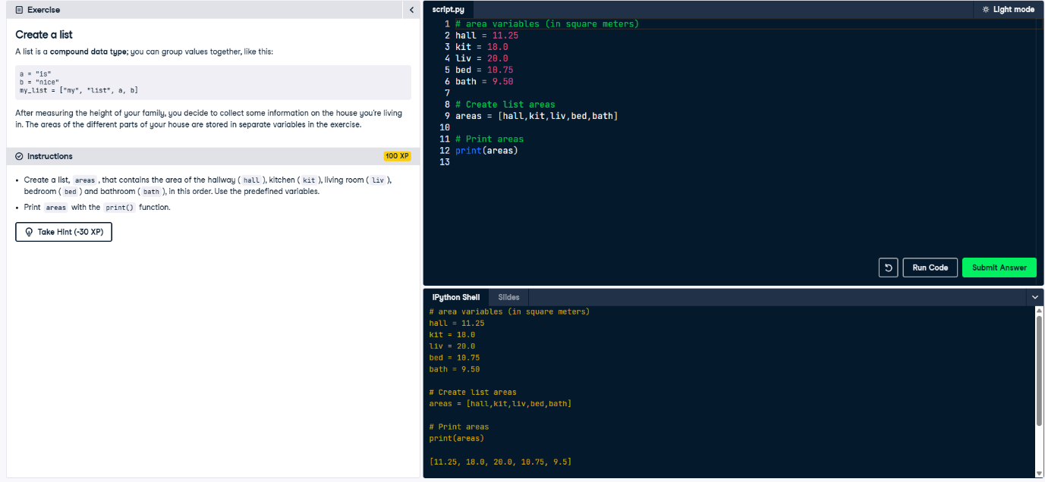

* [11.25, 18.0, 20.0, 10.75, 9.5]
* <script.py> output:

**

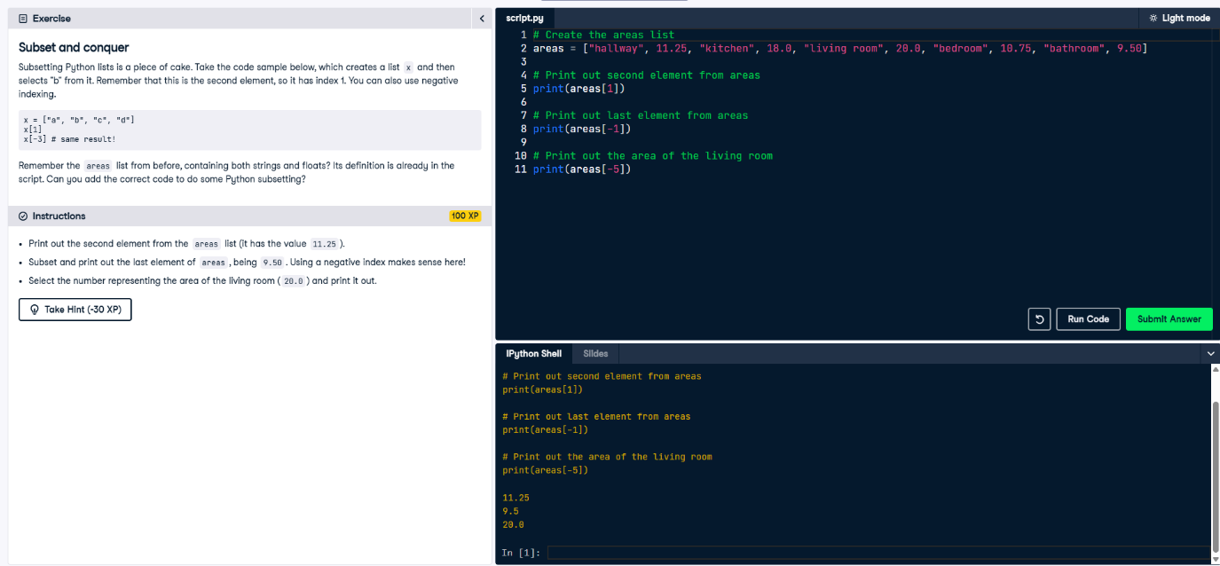

**Functions and Packages**

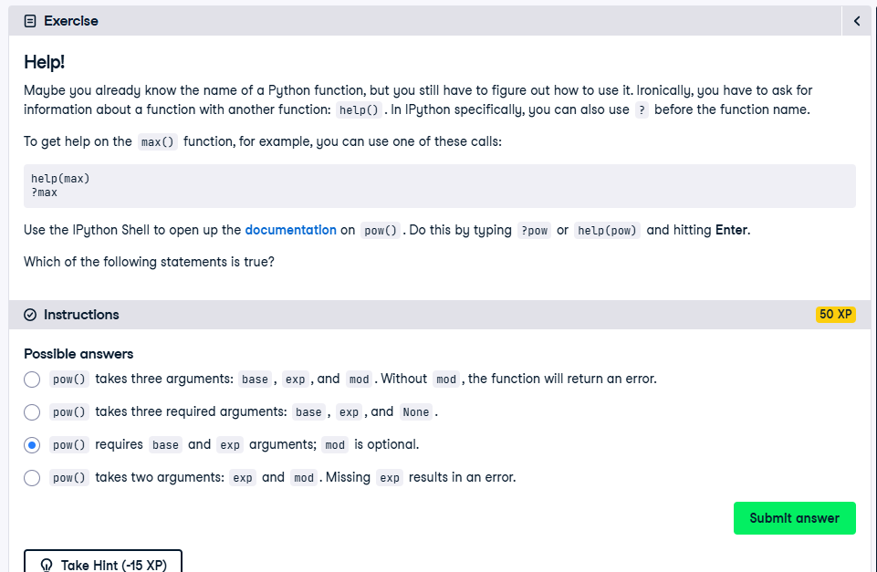

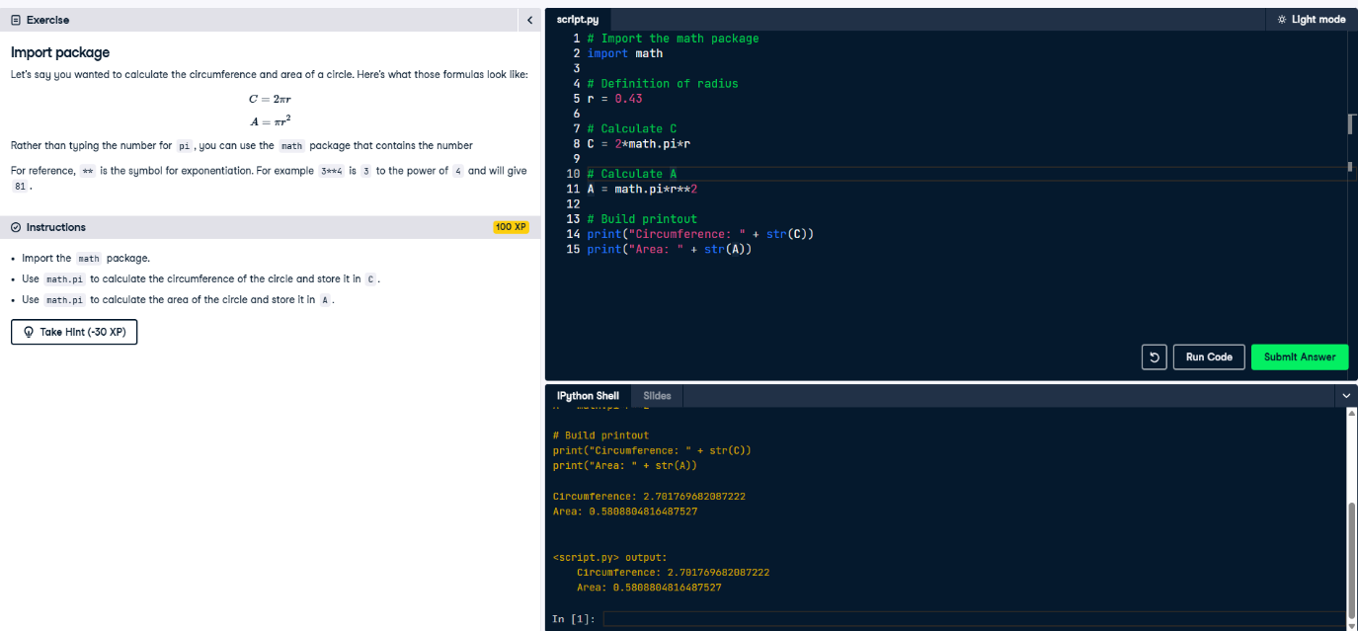

**Numpy**

